

Department of Psychology
401 Sunset Avenue, Windsor
Ontario, Canada N9B 3P4
T 519-253-3000 F 519-973-7021
www.uwindsor.ca/psychology
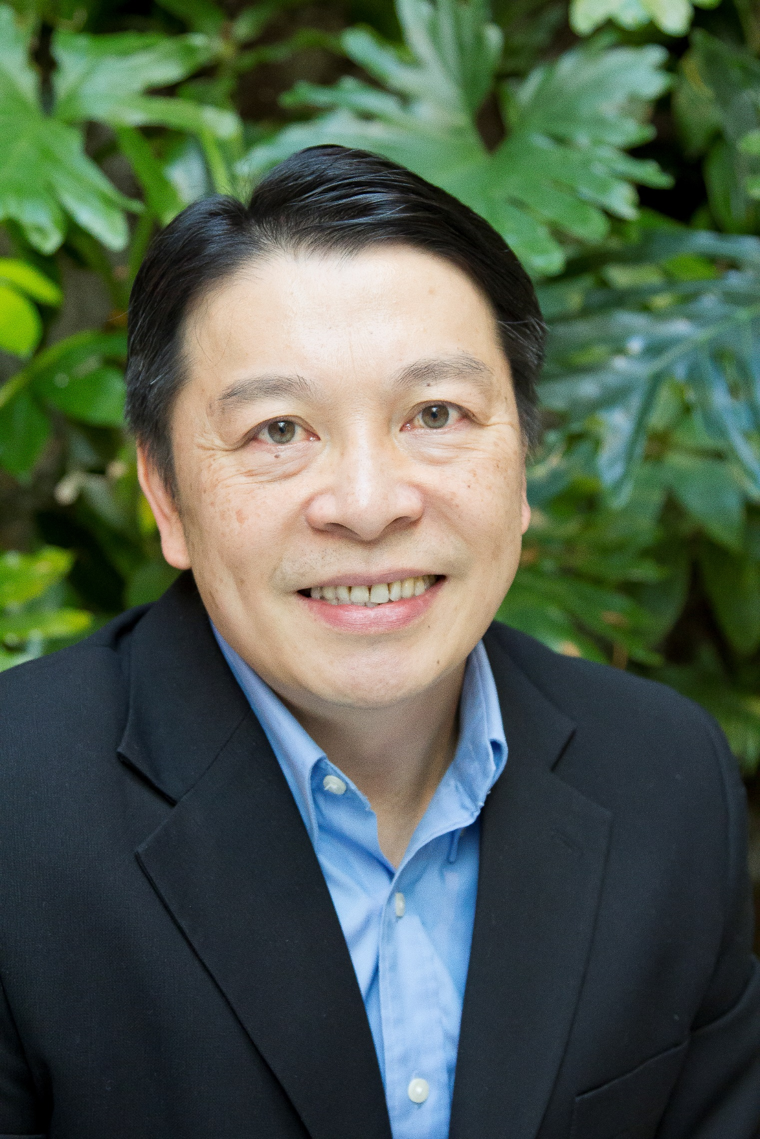

Brief Bio on Dr. Ben C. H. Kuo

Brief Biography:
Dr. Kuo is a full professor of clinical psychology at the Department of Psychology at the University of Windsor in Ontario, Canada. He is a Taiwanese-born and Canadian- and US- educated counselling psychologist who received his Ph.D. from the University of Nebraska-Lincoln, USA. Dr. Kuo conducts and publishes research in the broad areas of cross-cultural psychology and multicultural counselling and training; he also teaches undergraduate and graduate courses and offers training workshops in these areas regularly in Canada and internationally. Specifically, Dr. Kuo’s main research focuses on the topics of acculturation, cultural stress and coping, professional help-seeking attitude and behaviors, and cultural adjustment and mental health issues among immigrants, refugees, international students and racially/ethnically diverse populations. Dr. Kuo publishes regularly on top refereed journals in the areas described above and in various book chapters, and he has obtained grant-supported funding for his research project. In 2018, Dr. Kuo served as the guest editor for the special issue of Psycnopsis – the official communiqué of the Canadian Psychological Association – on “Refugee Mental Health.” Dr. Kuo received multiple distinctions for his research, teaching, and service. In 2017, Dr. Kuo was awarded the University of Windsor Outstand Research Award: Established Researcher/Scholar Category (the highest distinction/honour for research achievement of the university), as well as the Faculty of Humanities, Arts and Social Sciences’ Dr. Kathleen E. McCrone Teaching Award. Most recently, in 2019 Dr. Kuo received the Mary Lou Dietz Equity Leadership Award – a prestigious award bestowed by the Windsor University Faculty Association’s Status of Women, Diversity, and Equity Action Committee for Dr. Kuo’s commitment and contribution to the promotion and advancement of cultural diversity, multiculturalism, inclusivity, and social justice.
http://www.uwindsor.ca/dailynews/2019-04-10/faculty-association-honour-psych-prof-contributions-equity
Clinically, Dr. Kuo is a registered and practicing psychologist in Ontario, Canada. His clinical experiences extend to clients of diverse backgrounds and issues/concerns, including ethnic and non-ethnic individuals dealing with adjustment, relational, psychological and family problems, and survivors of traumas due to domestic violence, physical and sexual abuse, political torture and physical injury. Dr. Kuo designs and teaches graduate students in clinical and counselling psychology programs through supervised multicultural psychotherapy practicum and course on a regular basis. In particular, he is experienced in training and supervising psychologists, counsellors and mental health practitioners in the development of multicultural clinical/counselling competencies and the provision of culturally and linguistically responsive psychological interventions to clients of diverse backgrounds. Dr. Kuo’s recent clinical work and training focus on mental health well-being and intervention for trauma and torture recovery of refugees.

Furthermore, Dr. Kuo travels internationally and has lectured and provided training workshops in Taiwan, China, Thailand, Australia, New Zealand, Russia, Brazil, U.S., and Canada; he has been a distinguished visiting professor in several major universities in these countries. Dr. Kuo is also an active communicator of psychology. He has served regularly as speaker at numerous conferences and events for public, community and religious organizations and audiences and a consultant for community-based agencies. Finally, as a first-generation Taiwan Canadian immigrant, Dr. Kuo is fluent in Mandarin, Taiwanese, and Cantonese. He is intimately familiar with the psychosocial issues facing international students, immigrants, refugees and newcomers’ families and working with these populations. For more information about Dr. Kuo, visit his faculty website http://www1.uwindsor.ca/benkuo/.

Ben C. H. Kuo, Ph.D., Certified Psychologist
Professor of Clinical Psychology
University of Windsor
Department of Psychology
401 Sunset Avenue, Chrysler Hall S. Room 261-1
Windsor, ON. CANADA N9B 3P4
Tel: (519) 253-3000, Ext. 2238
Fax: (519) 973-7021
Email: benkuo@uwindsor.ca

